Formal system

Definition
# Source: Wiki source: Provided by: [Data Path: Persons Table -> ID Column: 1, Name_En Column: Motasem Essam] -> From: [Data Path: Sources Table -> ID Column: 15, Content Title Column: Wiki Source - Formal system] -> at: [Document, page: 1, Top, “formal system is…theorems from axioms.”] on [7/17/2025]
*A formal system is an abstract structure and formalization of an axiomatic system used for deducing, using rules of inference, theorems from axioms.^{[1]}
# Source: AI Source: Provided by: [Data Path: Persons Table -> ID Column: 1, Name_En Column: Motasem Essam] -> From: [ChatGPT] on [7/17/2025]
*A formal system is a set of rules and symbols used to generate and manipulate statements, typically in the context of logic or mathematics.
*A formal system consists of a language over some alphabet of symbols together with (axioms and) inference rules that distinguish some of the strings in the language as theorems.

Mathematical formal systems consist of the following
# Source: Wiki source: Provided by: [Data Path: Persons Table -> ID Column: 1, Name_En Column: Motasem Essam] -> From: [Data Path: Sources Table -> ID Column: 15, Content Title Column: Wiki Source - Formal system] -> at: [Document, page: 1, Concepts, “A formal system has…semidecidable sets, respectively.”] on [7/17/2025]
*A formal system has the following components, as a minimum:^{[3][4][5]}
- Formal language, which is a set of well-formed formulas, which are strings of symbols from an alphabet, formed by a formal grammar (consisting of production rules or formation rules).
- Deductive system, deductive apparatus, or proof system, which has rules of inference that take axioms and infers theorems, both of which are part of the formal language.
- In some cases an inductive system, used to derive a proof by first establishing a simple case, then generalizing it.
A formal system is said to be recursive (i.e. effective) or recursively enumerable if the set of axioms and the set of inference rules are decidable sets or semidecidable sets, respectively.
# Source: AI Source: Provided by: [Data Path: Persons Table -> ID Column: 1, Name_En Column: Motasem Essam] -> From: [ChatGPT] on [7/17/2025]
*A formal system is a set of rules and symbols used to create a structure for logical reasoning and mathematical proofs. It consists of the following key components:
- Alphabet (or Set of Symbols): A finite set of symbols or characters used to form expressions, which are usually strings of these symbols.
- Axioms (or Postulates): A set of basic, self-evident assumptions or truths from which other propositions are derived. Axioms are the foundational building blocks of the formal system.
- Rules of Inference: A set of rules that determine how one can derive new statements or conclusions from existing ones. These rules guide the logical progression within the system.
- Theorems: Statements that are proven or derived from axioms using the rules of inference.
- Formal Language: A well-defined set of syntactic rules that dictate how symbols can be combined to form valid expressions or formulas.

Examples
# Source: AI Source: Provided by: [Data Path: Persons Table -> ID Column: 1, Name_En Column: Motasem Essam] -> From: [ChatGPT] on [7/17/2025]
- A formal system is like a game in which tokens are manipulated according to rules in order to see what configurations can be obtained. Examples: chess, checkers, go, tic-tac-toe.

- Construction toys (like Lego), can be thought as formal systems. You have a set of tokens, and rules are based on physical restrictions.
- The “MU Puzzle” proposed by Hofstadter in his GEB book.
- Peano axioms which describe natural numbers with 0 and +1 (successor operation).
- Euclidean geometry which builds a set of rules based on a small set of axioms.
- John Conway’s Game of Life consists of a field of cels and rules which define the state of the board on the next move.

Key Concepts and Definitions in Formal Systems
# Source: Person Source: Provided by: [Data Path: Persons Table -> ID Column: 1, Name_En Column: Motasem Essam] Written by: [Data Path: Persons Table -> ID Column: 1, Name_En Column: Motasem Essam] on [7/17/2025]
- Abstract structure
- Formalization
- Axiom
- Axiomatic system
- Theorems
- Inference rules

1-Abstract structure

Definition
# Source: Wiki source: Provided by: [Data Path: Persons Table -> ID Column: 1, Name_En Column: Motasem Essam] -> From: [Data Path: Sources Table -> ID Column: 16, Content Title Column: Wiki Source - Abstract structure] -> at: [Document, page: 1, Top, “In mathematics and related…Kasparovian approaches).”] on [7/17/2025]
*In mathematics and related fields, an abstract structure is a way of describing a set of mathematical objects and the relationships between them, focusing on the essential rules and properties rather than any specific meaning or example.^{[1][2]}
For example, in a game such as chess, the rules of how the pieces move and interact define the structure of the game, regardless of whether the pieces are made of wood or plastic. Similarly, an abstract structure defines a framework of objects, operations, and relationships. These structures are studied in their own right, revealing fundamental mathematical principles. While a real-world object or computer program might represent, instantiate, or implement an abstract structure, the structure itself exists as an abstract concept, independent of any particular representation.
This abstraction allows to see common patterns across seemingly different areas of mathematics and to apply the same reasoning and tools to analyze them. Abstract structures are studied not only in logic and mathematics but in the fields that apply them, as computer science and computer graphics, and in the studies that reflect on them, such as philosophy (especially the philosophy of mathematics).
An abstract structure has a richer structure than a concept or an idea. An abstract structure must include precise rules of behaviour which can be used to determine whether a candidate implementation actually matches the abstract structure in question, and it must be free from contradictions. Thus we may debate how well a particular government fits the concept of democracy, but there is no room for debate over whether a given sequence of moves is or is not a valid game of chess (for example Kasparovian approaches).

Key Components of Abstract Structures
# Source: AI Source: Provided by: [Data Path: Persons Table -> ID Column: 1, Name_En Column: Motasem Essam] -> From: [ChatGPT] on [7/17/2025]
The key components of abstract structures generally depend on the field in which they are applied. However, several universal components can be identified that are commonly found across different domains. Here’s a breakdown of the typical key components of abstract structures:
- Elements/Entities
- Operations/Functions
- Axioms/Rules
- Relationships
- Properties
- Symmetry/Invariant Characteristics
- Identity/Neutral Elements
- Closure
- Substructures (or Subsets)
- Mappings/Transformations

1. Elements/Entities
# Source: AI Source: Provided by: [Data Path: Persons Table -> ID Column: 1, Name_En Column: Motasem Essam] -> From: [ChatGPT] on [7/17/2025]
- Definition: The individual objects or entities that make up the structure. Or The fundamental building blocks of any abstract structure. These can be numbers, objects, data points, or abstract concepts.
- Example: In a group (a mathematical abstract structure),In a set, the elements are the individual members of the set (e.g., integers under addition).

2. Operations/Functions
# Source: AI Source: Provided by: [Data Path: Persons Table -> ID Column: 1, Name_En Column: Motasem Essam] -> From: [ChatGPT] on [7/17/2025]
- Definition: functions that define how elements of the structure interact with each other Or Operations or functions are the processes that can be applied to the elements of the abstract structure. These operations may include addition, multiplication, concatenation, or other operations that define how elements interact.
- Example: In a vector space, the operations include vector addition and scalar multiplication. In a group, the operation could be addition or multiplication.

3. Axioms/Rules
# Source: AI Source: Provided by: [Data Path: Persons Table -> ID Column: 1, Name_En Column: Motasem Essam] -> From: [ChatGPT] on [7/17/2025]
- Definition: Fundamental principles or statements that define the properties and behaviors of the structure. Or These are the formal rules or properties that govern how elements and operations behave within the structure. Axioms are essential to defining the structure’s properties and constraints.
- Example: In a group, the axioms include closure (the operation on two elements results in another element of the set), the existence of an identity element, and the existence of inverses for each element. The axioms of a vector space include properties like associativity and distributivity.

4. Relationships
# Source: AI Source: Provided by: [Data Path: Persons Table -> ID Column: 1, Name_En Column: Motasem Essam] -> From: [ChatGPT] on [7/17/2025]
- Definition: The connections or associations between the elements within the structure. Or The relationships describe how elements are connected or interact with each other within the structure. This can involve hierarchy, associations, or other forms of interaction.
- Example: In a graph (a mathematical structure), the relationships are represented by edges connecting nodes (vertices).

5. Properties
# Source: AI Source: Provided by: [Data Path: Persons Table -> ID Column: 1, Name_En Column: Motasem Essam] -> From: [ChatGPT] on [7/17/2025]
- Definition: Properties are characteristics or attributes that are true about the abstract structure as a whole, based on the axioms or operations applied.
- Example: In a ring, one of the properties is that the multiplication operation is distributive over addition.

6. Symmetry/Invariant Characteristics
# Source: AI Source: Provided by: [Data Path: Persons Table -> ID Column: 1, Name_En Column: Motasem Essam] -> From: [ChatGPT] on [7/17/2025]
- Definition: Many abstract structures have symmetries or invariants—features that remain unchanged under certain transformations or operations.
- Example: In geometry, the symmetry of a shape (like a circle being invariant under rotation) is a key component of its abstract structure.

7. Identity/Neutral Elements
# Source: AI Source: Provided by: [Data Path: Persons Table -> ID Column: 1, Name_En Column: Motasem Essam] -> From: [ChatGPT] on [7/17/2025]
- Definition: Some abstract structures require an identity or neutral element, which doesn’t change other elements when combined with them using the defined operations.
- Example: In a group, the identity element is one that does not alter any other element when combined with it under the group operation (e.g., 0 for addition in the set of integers).

8. Closure
# Source: AI Source: Provided by: [Data Path: Persons Table -> ID Column: 1, Name_En Column: Motasem Essam] -> From: [ChatGPT] on [7/17/2025]
- Definition: Closure refers to the property that applying the defined operations on elements of the structure results in elements that are also within the structure.
- Example: In the set of integers with addition, the sum of any two integers is always an integer, so the set of integers is closed under addition.

9. Substructures (or Subsets)
# Source: AI Source: Provided by: [Data Path: Persons Table -> ID Column: 1, Name_En Column: Motasem Essam] -> From: [ChatGPT] on [7/17/2025]
- Definition: Some abstract structures have substructures or subsets that exhibit similar properties as the whole structure but on a smaller scale.
- Example: In group theory, a subgroup is a smaller group that follows the same rules as the larger group.

10. Mappings/Transformations
# Source: AI Source: Provided by: [Data Path: Persons Table -> ID Column: 1, Name_En Column: Motasem Essam] -> From: [ChatGPT] on [7/17/2025]
- Definition: Mappings or transformations can describe how elements from one abstract structure are related or mapped to elements of another structure.
- Example: In algebra, a homomorphism is a map between two groups that preserves the group operation.

Examples

Normal Example
# Source: Wiki source: Provided by: [Data Path: Persons Table -> ID Column: 1, Name_En Column: Motasem Essam] -> From: [Data Path: Sources Table -> ID Column: 16, Content Title Column: Wiki Source - Abstract structure] -> at: [Document, page: 1, Examples, “A sorting algorithm…debate and interpretation.”] on [7/17/2025]
- A sorting algorithm is an abstract structure, but a recipe is not, because it depends on the properties and quantities of its ingredients.
- A simple melody is an abstract structure, but an orchestration is not, because it depends on the properties of particular instruments.
- Euclidean geometry is an abstract structure, but the theory of continental drift is not, because it depends on the geology of the Earth.
- A formal language is an abstract structure, but a natural language is not, because its rules of grammar and syntax are open to debate and interpretation.

More Normal Example
# Source: AI Source: Provided by: [Data Path: Persons Table -> ID Column: 1, Name_En Column: Motasem Essam] -> From: [ChatGPT] on [7/17/2025]
- Sets:
  - A collection of distinct elements.
  - Operations: Union, intersection, complement.
  - Example: Set of natural numbers {1,2,3,…}

- Groups:
  - A set equipped with a single operation that satisfies specific axioms (closure, associativity, identity element, and inverses).
  - Example: The set of integers with addition as the operation (Z,+).
- Graphs:
  - A set of vertices (nodes) and a set of edges (connections) between them.
  - Example: A network of connected computers.
- Vector Spaces:
  - A collection of vectors that can be added together and multiplied by scalars, satisfying specific axioms.
  - Example: The space of all 2-dimensional vectors R².
- Algebraic Structures:
  - Structures that include sets and operations, such as rings, fields, and lattices.
  - Example: The set of real numbers with addition and multiplication (R,+,⋅).

Examples of Abstract Structures and their Components:
# Source: AI Source: Provided by: [Data Path: Persons Table -> ID Column: 1, Name_En Column: Motasem Essam] -> From: [ChatGPT] on [7/17/2025]
- Mathematical Structure (e.g., Group Theory):
  - Elements: Numbers or objects (e.g., integers).
  - Operations: Addition, multiplication, etc.
  - Axioms: Closure, associativity, identity element, inverse elements.
  - Properties: Commutativity, distributivity (depending on the type of structure).

- Abstract Data Type (ADT):
  - Elements: Data items (e.g., numbers, strings, objects).
  - Operations: Push, pop (for stack), enqueue, dequeue (for queue).
  - Axioms: Stack follows LIFO (Last In, First Out), queue follows FIFO (First In, First Out).
  - Properties: Behavior defined by the operations, not implementation details.

- Graph Theory:
  - Elements: Nodes (vertices), edges (connections between nodes).
  - Operations: Adding/removing vertices or edges, finding paths, etc.
  - Relationships: The edges that connect nodes.
  - Properties: Connectivity, directed or undirected edges.
- Vector Space:
  - Elements: Vectors.
  - Operations: Vector addition, scalar multiplication.
  - Axioms: Closure, associativity, existence of an identity vector (zero vector), existence of inverses.
  - Properties: Linear independence, span, basis, and dimension.

Importance
# Source: AI Source: Provided by: [Data Path: Persons Table -> ID Column: 1, Name_En Column: Motasem Essam] -> From: [ChatGPT] on [7/17/2025]
- Simplification: Abstract structures allow for the simplification of complex systems by focusing on the essential properties and relationships.
- Generalization: They enable the generalization of concepts across different domains and applications.
- Formalization: Provide a rigorous framework for proving theorems and establishing consistency within a system.

2-Formalization
# Source: Wiki source: Provided by: [Data Path: Persons Table -> ID Column: 1, Name_En Column: Motasem Essam] -> From: [Data Path: Sources Table -> ID Column: 19, Content Title Column: Wiki Source - Formalism (philosophy of mathematics)] -> at: [Document, page: 1, Top, “In the philosophy of mathematics… purely formal methods.”] on [7/17/2025]
*In the philosophy of mathematics, formalism is the view that holds that statements of mathematics and logic can be considered to be statements about the consequences of the manipulation of strings (alphanumeric sequences of symbols, usually as equations) using established manipulation rules. A central idea of formalism "is that mathematics is not a body of propositions representing an abstract sector of reality, but is much more akin to a game, bringing with it no more commitment to an ontology of objects or properties than ludo or chess."^{[1]}

According to formalism, mathematical statements are not "about" numbers, sets, triangles, or any other mathematical objects in the way that physical statements are about material objects. Instead, they are purely syntactic expressions—formal strings of symbols manipulated according to explicit rules without inherent meaning. These symbolic expressions only acquire interpretation (or semantics) when we choose to assign it, similar to how chess pieces follow movement rules without representing real-world entities. This view stands in stark contrast to mathematical realism, which holds that mathematical objects genuinely exist in some abstract realm.
Formalism emerged as a response to foundational crises in mathematics during the late nineteenth and early twentieth centuries, particularly concerns about paradoxes in set theory and questions about the consistency of mathematical systems. It represents one of the three major philosophical approaches to mathematics developed during this period, alongside logicism and intuitionism, though formalism encompasses a broader spectrum of positions than these more narrowly defined views. Among formalists, the German mathematician David Hilbert was the most influential advocate, developing what became known as Hilbert's program to establish the consistency of mathematics through purely formal methods.^{[2]}
# Source: AI Source: Provided by: [Data Path: Persons Table -> ID Column: 1, Name_En Column: Motasem Essam] -> From: [ChatGPT] on [7/17/2025]
*Formalization refers to the process of converting informal concepts, ideas, or systems into a structured and well-defined format, often using specific rules or languages. It is commonly used in various fields such as mathematics, logic, linguistics, computer science, and social sciences. The goal of formalization is to make something more precise, clear, and unambiguous.
In different contexts, formalization can mean:
- Mathematics and Logic: Converting verbal statements or informal reasoning into formal symbols, axioms, or logical systems, which can then be analyzed or manipulated according to strict rules.
- Computer Science: Developing algorithms, programming languages, or systems that follow clear, precise definitions to ensure correctness and consistency in execution.
- Linguistics: Turning natural language into a formal system to study the structure and rules of languages (e.g., syntax, semantics).
- Social Sciences: Systematizing theories or models to create structured frameworks that can be tested, evaluated, or analyzed rigorously.
The aim of formalization is to reduce ambiguity, enhance clarity, and often to facilitate computation or logical analysis.

3-Axiom

Definition
# Source: Wiki source: Provided by: [Data Path: Persons Table -> ID Column: 1, Name_En Column: Motasem Essam] -> From: [Data Path: Sources Table -> ID Column: 18, Content Title Column: Wiki Source - Axiom] -> at: [Document, page: 1, Top, “An axiom, postulate… itself as evident'.^{[1][2]}”] on [7/17/2025]
*An axiom, postulate, or assumption is a statement that is taken to be true, to serve as a premise or starting point for further reasoning and arguments. The word comes from the Ancient Greek word ἀξίωμα (axíōma), meaning 'that which is thought worthy or fit' or 'that which commends itself as evident'.^{[1][2]}
# Source: AI Source: Provided by: [Data Path: Persons Table -> ID Column: 1, Name_En Column: Motasem Essam] -> From: [ChatGPT] on [7/17/2025]
*In general:
a statement or proposition which is regarded as being established, accepted, or self-evidently true, or universally accepted principle.

*In math:
A foundational assumption or starting point in a mathematical theory, accepted without proof, and used to derive further results.

Key Concepts and Definitions in Axiom

I-Proposition

Proposition Definition
# Source: Multi sources: Provided by: [Data Path: Persons Table -> ID Column: 1, Name_En Column: Motasem Essam] -> From: [Data Path: Sources Table -> ID Column: 24, Content Title Column: Multi Sources - Propositions] -> at: [Document, page: 1, PROPOSITIONS, “A proposition is... but not both.”] on [7/17/2025]
*A proposition is a declarative sentence that is either true or false, but not both.

# Source: AI Source: Provided by: [Data Path: Persons Table -> ID Column: 1, Name_En Column: Motasem Essam] -> From: [ChatGPT] on [7/17/2025]
*In general:
a statement or assertion that expresses a judgement or opinion.

*In logic:
a statement that expresses a concept that can be true or false.

In math:
a formal statement of a theorem or problem, typically including the demonstration.

EXAMPLES OF PROPOSITIONS
# Source: Multi sources: Provided by: [Data Path: Persons Table -> ID Column: 1, Name_En Column: Motasem Essam] -> From: [Data Path: Sources Table -> ID Column: 24, Content Title Column: Multi Sources - Propositions] -> at: [Document, page: 1, EXAMPLES OF PROPOSITIONS, “Examples. The following... = 5.”] on [7/17/2025]

Examples. The following sentences are propositions.
1. Houston is located in Harris County.
2. San Antonio is the capital of Texas.
3. 2+2 = 4.
4. 2+1 = 5.

NOT ALL SENTENCES ARE PROPOSITIONS
# Source: Multi sources: Provided by: [Data Path: Persons Table -> ID Column: 1, Name_En Column: Motasem Essam] -> From: [Data Path: Sources Table -> ID Column: 24, Content Title Column: Multi Sources - Propositions] -> at: [Document, page: 1, NOT ALL SENTENCES ARE PROPOSITIONS, “Examples. Examples. The following... = if x = 5, otherwise it is false.”] on [7/17/2025]
Examples. The following sentences are not propositions.
      - Is the sun shining?
      - Work Problems 4 and 5 at the end of Section
      - Turn in your paper now!
      - x+2 = 7.
Interrogative, imperative and exclamatory sentences are not propositions. As it stands, Sentence 4 is not a proposition. It becomes a proposition if the value of x is known. Of course it is true if x = 5, otherwise it is false.

II-Statement and sentence

Statement Definition
# Source: AI Source: Provided by: [Data Path: Persons Table -> ID Column: 1, Name_En Column: Motasem Essam] -> From: [ChatGPT] on [7/17/2025]
*A "statement" generally refers to a clear expression or declaration of something, often made in writing or speech. Its meaning can vary depending on the context:
- In general language use: A statement is a declarative sentence or assertion that provides information or expresses an idea, opinion, or fact. For example, "The sky is blue" is a statement.
- In programming: A statement is a single instruction that a program executes. For example, in languages like Python, a statement could be something like x = 10, which assigns the value 10 to a variable x.
- In finance: A statement often refers to a document that provides a summary of an account's activity, such as a bank statement, which shows transactions, balances, and other financial details.
- In law: A statement is a formal oral or written account, often given as evidence or testimony, about a certain situation, incident, or issue.
- In logic and mathematics: A statement is a declarative sentence that is either true or false but not both. For example, "2 + 2 = 4" is a statement that is true.
# Source: Wiki source: Provided by: [Data Path: Persons Table -> ID Column: 1, Name_En Column: Motasem Essam] -> From: [Data Path: Sources Table -> ID Column: 21, Content Title Column: Wiki Source - Proposition] -> at: [Document, page: 1, Statements, “In logic and… underlying number.^{[16]}”] on [7/17/2025]
*In logic and semantics, the term statement is variously understood to mean either:
- a meaningful declarative sentence that is true or false,^{[citation needed]} or
- a proposition. Which is the assertion that is made by (i.e., the meaning of) a true or false declarative sentence.^{[14][15]}
In the latter case, a (declarative) sentence is just one way of expressing an underlying statement. A statement is what a sentence means, it is the notion or idea that a sentence expresses, i.e., what it represents. For example, it could be said that "2 + 2 = 4" and "two plus two equals four" are two different sentences expressing the same statement. As another example, consider that the Arabic numeral '7', the Roman numeral 'VII', and the English word 'seven' are all distinct from the underlying number.^{[16]}

Sentence Definition
# Source: AI Source: Provided by: [Data Path: Persons Table -> ID Column: 1, Name_En Column: Motasem Essam] -> From: [ChatGPT] on [7/17/2025]
*A sentence is a group of words that expresses a complete thought or idea. It typically contains a subject (what or who the sentence is about) and a predicate (what the subject is doing or what is being said about the subject). Sentences can be as short as a single word or be very long, and they can vary in structure.

For example:
- "She runs." (simple sentence)
- "The dog barked loudly in the yard." (longer sentence with more details)
A sentence must have at least one independent clause (a subject and a verb that can stand alone) to be considered complete.

# Source: Wiki source: Provided by: [Data Path: Persons Table -> ID Column: 1, Name_En Column: Motasem Essam] -> From: [Data Path: Sources Table -> ID Column: 20, Content Title Column: Wiki Source - Sentence (linguistics)] -> at: [Document, page: 1, Top, “In linguistics and…the lazy dog."”] on [7/17/2025]
*In linguistics and grammar, a sentence is a linguistic expression, such as the English example "The quick brown fox jumps over the lazy dog."

Sentences Types
# Source: Wiki source: Provided by: [Data Path: Persons Table -> ID Column: 1, Name_En Column: Motasem Essam] -> From: [Data Path: Sources Table -> ID Column: 20, Content Title Column: Wiki Source - Sentence (linguistics)] -> at: [Document, page: 1, Classification -> By function or speech act, “Sentences can also be classified…friend you are!"”] on [7/17/2025]
Sentences can also be classified based on the speech act which they perform. For instance, English sentence types can be described as follows:
- A declarative sentence makes a statement or assertion:
  - "You are my friend."
- An interrogative sentence raises a question:
  - "Are you my friend?"
- An imperative sentence makes a command:
  - "Be my friend!"
- An exclamative or exclamatory sentence raises an exclamation:
  - "What a good friend you are!"

Statement vs Assertion
# Source: AI Source: Provided by: [Data Path: Persons Table -> ID Column: 1, Name_En Column: Motasem Essam] -> From: [ChatGPT] on [7/17/2025]
*The terms "assertion" and "statement" are often used interchangeably, but they can have slightly different meanings depending on the context. Let's break it down:
1. In general usage:
- Statement: A statement is any sentence or declaration that provides information, expresses an idea, or conveys something. It can be a fact, an opinion, or an observation. A statement could be true or false.
  - Example: "The Earth revolves around the Sun." (This is a statement of fact.)
  - Example: "I like pizza." (This is a statement of opinion.)
- Assertion: An assertion is a type of statement, but it typically emphasizes that something is being strongly declared or affirmed. It implies a confident or forceful claim, often without immediate proof or evidence.
  - Example: "The Earth is flat." (This is an assertion, often made with strong conviction, though it's factually incorrect.)
  - Example: "I assert that I have never lied." (Here, the speaker is confidently declaring something as true.)
2. In logic:
- Statement: In logic, a statement (also called a proposition) is a declarative sentence that can be either true or false, but not both. Statements are often the building blocks of logical reasoning.
  - Example: "2 + 2 = 4" (This is a statement, and it is true.)
  - Example: "5 is greater than 10" (This is a statement, and it is false.)
- Assertion: In logical terms, an assertion is the act of affirming that a particular statement is true. An assertion typically involves a declarative sentence that presents a proposition to be accepted or rejected. Assertions may be subject to logical analysis or argument.
  - Example: "I assert that 2 + 2 equals 4." (You're not just stating the fact; you're claiming it to be true and asserting your belief in its truth.)
3. In programming:
- Statement: In programming, a statement is a single instruction or command that the computer executes. For example, variable assignments, function calls, and loops are all types of statements in programming.
  - Example: x = 5; (This is an assignment statement in Python.)
- Assertion: In programming, an assertion is a statement used to check if a condition is true during program execution. If the condition evaluates to false, an error is raised (or the program might stop). Assertions are typically used for debugging.
  - Example: assert x > 0; (This checks that x is greater than 0, and if it's not, the program will raise an error.)
Key Differences:
- Assertion: Tends to emphasize a strong declaration or belief in something. It often implies confidence, and in logical or philosophical contexts, it can be a forceful statement of belief or truth.
- Statement: A broader term, referring to any declarative sentence that expresses an idea, fact, or opinion, without necessarily implying forceful or confident assertion.
Conclusion:
While all assertions are statements (because they declare something), not all statements are assertions. An assertion often carries a sense of confidence or emphasis, while a statement is just a declaration of something that can be true or false.
# Source: Multi sources: Provided by: [Data Path: Persons Table -> ID Column: 1, Name_En Column: Motasem Essam] -> From: [Data Path: Sources Table -> ID Column: 23, Content Title Column: Multi Sources - Assertion vs Statement] -> at: [Document, page: 2, 3 Answers, “an assertion claims...judged as true/false.”] on [7/17/2025]
* an assertion claims the reference of sentence, a statement is a sentence with a truth value, and a statement can be judged as true/false.

Statement vs Sentence
# Source: AI Source: Provided by: [Data Path: Persons Table -> ID Column: 1, Name_En Column: Motasem Essam] -> From: [ChatGPT] on [7/17/2025]
The terms "sentence" and "statement" are related but have distinct meanings depending on the context:
1. In general language use:
- Sentence: A sentence is a grammatical unit that expresses a complete thought. It can consist of a single word (like "Go.") or multiple words. A sentence can be a question, command, exclamation, or declaration.
  - Example: "She is reading a book." (This is a declarative sentence.)
  - Example: "Are you coming to the party?" (This is an interrogative sentence.)
- Statement: A statement is a specific type of sentence that makes a declaration or expresses information. A statement can be true or false and typically provides a fact, opinion, or observation.
  - Example: "The sky is blue." (This is a statement because it declares a fact.)
  - Example: "I enjoy hiking." (This is a statement expressing an opinion.)

Difference:
- All statements are sentences (because a statement is a type of sentence), but not all sentences are statements. For instance, questions ("What time is it?") and commands ("Close the door.") are sentences, but they aren't considered statements because they don't declare something.
2. In logic or mathematics:
- Sentence: In logic, a sentence is a symbolic expression that can be either true or false. It is a statement that follows logical structure.
  - Example: "2 + 2 = 4" is a logical sentence that is true.
- Statement: A statement in logic is a declarative sentence that is either true or false but not both. It is the specific assertion made by a sentence.
  - Example: "5 > 3" is a statement because it asserts something that is true.
Difference: In logical terms, the word "statement" is often used more specifically to refer to something that has a truth value (true or false), while a "sentence" is any linguistic structure or expression that can be evaluated for truth.
3. Summary of Differences:
- Sentence: A general term for any complete thought, expressed as a grammatically correct unit. Sentences can be questions, commands, exclamations, or declarations.
- Statement: A type of sentence that asserts something that can be true or false.
So, while a statement is always a sentence, a sentence is not always a statement. It depends on whether the sentence is making a declaration (statement) or asking something (question) or giving a command.
# Source: Multi sources: Provided by: [Data Path: Persons Table -> ID Column: 1, Name_En Column: Motasem Essam] -> From: [Data Path: Sources Table -> ID Column: 25, Content Title Column: Multi Sources - Sentence or Statement] -> at: [Document, page: 1, Answer, “A sentence is a...or exclamation point.”] on [7/17/2025]
*A sentence is a group of words that usually have a subject, verb and information about the subject.

Remember: A sentence can be a statement, question or command.

A statement is a basic fact or opinion. It is one kind of sentence. It usually ends with a period or exclamation point.

Statement vs Sentence vs Assertion
# Source: AI Source: Provided by: [Data Path: Persons Table -> ID Column: 1, Name_En Column: Motasem Essam] -> From: [ChatGPT] on [7/17/2025]
The terms "statement," "sentence," and "assertion" are closely related but have distinct meanings, especially in logic and philosophy. Here's how they differ:
1. Sentence:
A sentence is a grammatical unit that conveys a complete thought. It consists of words arranged in a way that follows the rules of grammar. A sentence can be a statement, question, command, or exclamation.
- Example: "The sky is blue."
- It is simply a sequence of words structured according to the rules of language.
2. Statement:
A statement is a type of sentence that can be judged as either true or false. In logic, a statement is a declarative sentence that conveys information, and its truth value can be verified.
- Example: "The Earth revolves around the Sun."
- It’s a declarative sentence, which makes a claim that can be true or false.

3. Assertion:
An assertion is a specific kind of statement in which the speaker not only makes a claim but also expresses confidence or conviction in the truth of that claim. In a way, all assertions are statements, but not all statements are necessarily assertions.
- Example: "I assert that the Earth is round."
- An assertion is often more forceful or emphatic than just a plain statement, indicating that the speaker strongly believes or insists the claim is true.
Key Differences:
- Sentence: A grammatical unit.
- Statement: A sentence that conveys a truth claim and can be evaluated as true or false.
- Assertion: A type of statement where the speaker expresses belief or conviction about the claim.
In summary:
- A sentence is just a group of words forming a thought.
- A statement is a sentence that can be true or false.
- An assertion is a statement made with conviction.

EXAMPLES OF axioms
# Source: AI Source: Provided by: [Data Path: Persons Table -> ID Column: 1, Name_En Column: Motasem Essam] -> From: [ChatGPT] on [7/17/2025]
Axioms are foundational statements or principles that are accepted as true without needing proof. They serve as the building blocks for logical systems and mathematical theories. Here are some examples from different fields:
1. Mathematics
- Axiom of Equality: For any two things, if they are equal to the same thing, they are equal to each other. (e.g., If a=ba = ba=b and b=cb = cb=c, then a=ca = ca=c).
- Axiom of Existence: There exists at least one element in a given set. (e.g., There exists at least one number in the set of real numbers).
- Axiom of Addition: If aaa and bbb are numbers, then their sum, a+ba + ba+b, is also a number.
2. Geometry
- Euclid's Axioms: These are the basis of Euclidean geometry, like:
  - Axiom 1: A straight line segment can be drawn joining any two points.
  - Axiom 2: Any straight line segment can be extended indefinitely in a straight line.
  - Axiom 3: A circle can be drawn with any center and any radius.

3. Set Theory
- Axiom of Extensionality: Two sets are equal if they have exactly the same elements. (i.e., A=BA = BA=B if and only if for all xxx, x∈A ⟺ x∈Bx \in A \iff x \in Bx∈A⟺x∈B).
- Axiom of Pairing: For any two sets aaa and bbb, there is a set that contains exactly aaa and bbb as elements. (i.e., {a,b}\{a, b\}{a,b} is a set containing aaa and bbb).
4. Logic
- Axiom of the Law of Identity: Everything is identical to itself (i.e., A=AA = AA=A).
- Axiom of the Law of Noncontradiction: A statement cannot be both true and false at the same time (i.e., ¬(A∧¬A)\neg(A \land \neg A)¬(A∧¬A)).
- Axiom of the Law of the Excluded Middle: For any proposition, either the proposition is true, or its negation is true (i.e., A∨¬AA \lor \neg AA∨¬A).
5. Physics
- Axiom of Relativity (in Special Relativity): The laws of physics are the same for all observers in inertial frames of reference.
- Axiom of Conservation of Energy: The total energy in an isolated system remains constant over time.
6. Ethics (Philosophy)
- Axiom of Moral Equality: All human beings are of equal moral worth and should be treated with equal respect.
- Axiom of Reciprocity: Treat others as you would want to be treated (Golden Rule).
These axioms help to create frameworks within which further reasoning, theorems, and conclusions are drawn.

Assertion vs Axiom
# Source: AI Source: Provided by: [Data Path: Persons Table -> ID Column: 1, Name_En Column: Motasem Essam] -> From: [ChatGPT] on [7/17/2025]
Assertion and Axiom are both foundational concepts in logic and mathematics, but they have distinct meanings and uses.
1. Assertion:
- An assertion is a statement or claim that is presented as being true.
- It can be either true or false, but when made, it's treated as a fact or a proposition that can be evaluated.
- Assertions can be supported by evidence or reasoning, and they are often part of an argument or proof.
- For example, "The sum of two even numbers is even" is an assertion because it presents a claim about a mathematical fact, which can be proved or disproved.
Key Points:
- It is a declarative statement.
- Can be proved or disproved.
- Relies on evidence or reasoning for its truth value.
- May or may not be accepted in the context.
2. Axiom:
- An axiom is a foundational principle or statement assumed to be true without proof.
- Axioms serve as starting points for building a system of logic, mathematics, or a theory.
- Axioms are generally accepted because they are seen as self-evident or universally applicable within a specific framework.
- In mathematics, axioms form the basic building blocks of a logical system (e.g., Euclidean geometry has its own set of axioms).
Key Points:
- It is a self-evident or assumed truth.
- It does not need proof.
- Serves as a starting point for logical reasoning or mathematical theory.
- Accepted within a particular framework or system.
Example:
- Assertion: "All prime numbers greater than 2 are odd." (This can be checked and proven.)
- Axiom: "Through any two points, there is exactly one straight line." (This is assumed as true in Euclidean geometry and doesn't require proof.)
Summary:
- Assertion: A claim or statement that can be proven or disproven.
- Axiom: A basic, self-evident truth accepted without proof, forming the foundation of a system.

4-Axiomatic system

Definition
# Source: Multi sources: Provided by: [Data Path: Persons Table -> ID Column: 1, Name_En Column: Motasem Essam] -> From: [Data Path: Sources Table -> ID Column: 26, Content Title Column: Multi Sources - The Axiomatic System - Definition & Properties] -> at: [Document, page: 1, Top, “In mathematics, the axiomatic... an axiomatic system.”] on [7/17/2025]
*In mathematics, the axiomatic system refers to the statements and rules used to develop and prove theorems. Explore the definition and properties of the axiomatic system, including consistency, independence, and completeness. Understand how an axiom compares to an axiomatic system.

# Source: Multi sources: Provided by: [Data Path: Persons Table -> ID Column: 1, Name_En Column: Motasem Essam] -> From: [Data Path: Sources Table -> ID Column: 26, Content Title Column: Multi Sources - The Axiomatic System - Definition & Properties] -> at: [Document, page: 1, The Axiomatic System, “What exactly is...are basic truths.”] on [7/17/2025]
*What exactly is an axiomatic system? I know it sounds like a big word for a complicated system, but it's actually not all that complicated.

Defined, an axiomatic system is a set of axioms used to derive theorems. What this means is that for every theorem in math, there exists an axiomatic system that contains all the axioms needed to prove that theorem.

An axiom is a statement that is considered true and does not require a proof. It is considered the starting point of reasoning. Axioms are used to prove other statements. They are basic truths.

Examples
# Source: Multi sources: Provided by: [Data Path: Persons Table -> ID Column: 1, Name_En Column: Motasem Essam] -> From: [Data Path: Sources Table -> ID Column: 26, Content Title Column: Multi Sources - The Axiomatic System - Definition & Properties] -> at: [Document, page: 1, The Axiomatic System, “For example,... three different properties.”] on [7/17/2025]
For example, the statement that all right angles are equal to each other is an axiom and does not require a proof. We know that all right angles are equal to each other and we do not argue that point. Instead, we use this information to prove other things. A collection of these basic, true statements forms an axiomatic system.
The subject that you are studying right now, geometry, is actually based on an axiomatic system known as Euclidean geometry. This system has only five axioms or basic truths that form the basis for all the theorems that you are learning. Everything can be traced back to these five axioms. What are they? Let me tell you.

1. A straight line can be drawn from any one point to any other point.
2. A line segment can be extended infinitely in both directions.
3. A circle can be described with a center and radius.
4. All right angles are equal to each other.
5. If a line intersecting two lines forms interior angles less than 90
degrees, then the two lines will intersect on the same side as the angles that are less than 90 degrees. The fifth axiom is also known as the parallel postulate. Axiomatic systems also have three different properties.

Axiomatic systems properties
# Source: Person Source: Provided by: [Data Path: Persons Table -> ID Column: 1, Name_En Column: Motasem Essam] Written by: [Data Path: Persons Table -> ID Column: 1, Name_En Column: Motasem Essam] on [7/17/2025]
Axiomatic systems also have three different properties. are Consistency, Independence, Completeness

Consistency
# Source: Multi sources: Provided by: [Data Path: Persons Table -> ID Column: 1, Name_En Column: Motasem Essam] -> From: [Data Path: Sources Table -> ID Column: 26, Content Title Column: Multi Sources - The Axiomatic System - Definition & Properties] -> at: [Document, page: 2, Consistency, “The first property...requirement for an axiomatic system.”] on [7/17/2025]
The first property is called consistency. When an axiomatic system is consistent, then the system will NOT be able to prove both a statement and its negation. The consistent system will prove either the statement or its negative, but not both. If it did, then it would contradict itself.

Example
For example, if an axiomatic system was able to prove the statement 'squares are made from two triangles' as well as the statement 'squares are not made from two triangles,' then the system is not consistent. The system actually contradicts itself. You can't rely on the system. Because of this, this property is a requirement for an axiomatic system.

Independence
# Source: Multi sources: Provided by: [Data Path: Persons Table -> ID Column: 1, Name_En Column: Motasem Essam] -> From: [Data Path: Sources Table -> ID Column: 26, Content Title Column: Multi Sources - The Axiomatic System - Definition & Properties] -> at: [Document, page: 2 to 3, Independence, “The next property is...is not a requirement for an axiomatic system.”] on [7/17/2025]
The next property is independence. The axioms in an axiomatic system are said to be independent if the axiom cannot be derived from the other axioms in the system. If you can use some of the axioms to prove another axiom in the system, then the system is not independent because one of the statements depends on the other statements.

Example
Look back at the five axioms of Euclidean geometry, for example, and you will see that this particular axiomatic system is independent since none of the five axioms can be proved by the other four. An axiomatic system does not have to be independent. It can be either dependent or independent, so this property, unlike the property for consistency, is not a requirement for an axiomatic system.

Completeness
# Source: Multi sources: Provided by: [Data Path: Persons Table -> ID Column: 1, Name_En Column: Motasem Essam] -> From: [Data Path: Sources Table -> ID Column: 26, Content Title Column: Multi Sources - The Axiomatic System - Definition & Properties] -> at: [Document, page: 3, Completeness, “The third property is...any axiomatic system.”] on [7/17/2025]
The third property is that of completeness. A complete axiomatic system is a system where for any statement, either the statement or its negative can be proved using the system. If there is any statement the system cannot prove or disprove, then the system is not complete. As you can see, this is a pretty big property to fill. This is why completeness is also not a required property. This property is a tough one to fulfill for any axiomatic system.

5-Theorems

Definition
# Source: AI Source: Provided by: [Data Path: Persons Table -> ID Column: 1, Name_En Column: Motasem Essam] -> From: [ChatGPT] on [7/17/2025]
*In general:
a theorem is a formula, proposition, or statement in mathematics or logic deduced or to be deduced from other formulas or propositions

In mathematics:
a theorem is a statement that has been proved, or can be proved.^{[a][2][3]}
The proof of a theorem is a logical argument that uses the inference rules of a deductive system to establish that the theorem is a logical consequence of the axioms and previously proved theorems.
In Physics:
a general proposition not self-evident but proved by a chain of reasoning; a truth established by means of accepted truths.
# Source: Multi sources: Provided by: [Data Path: Persons Table -> ID Column: 1, Name_En Column: Motasem Essam] -> From: [Data Path: Sources Table -> ID Column: 27, Content Title Column: Multi Sources - Theorem - Meaning, Types & Examples] -> at: [Document, page: 1 to 2, Theorem Definition, “In mathematics, a...members of a truss.”] on [7/17/2025]
*In mathematics, a theorem can be defined as a statement that can be proved to be true based on known and proven facts. These known facts may be of mathematical expressions or operations. According to the Oxford dictionary, the definition of the theorem is ''a rule or principle, especially in mathematics, that can be proved to be true''. For example, in mathematics, the Pythagorean theorem is a well-known theorem and is most widely used in the domain of science. The Pythagorean theorem states that the square of the hypotenuse of a right-angled triangle is equal to the sum of the squares of the sides of the triangle. Mathematically,
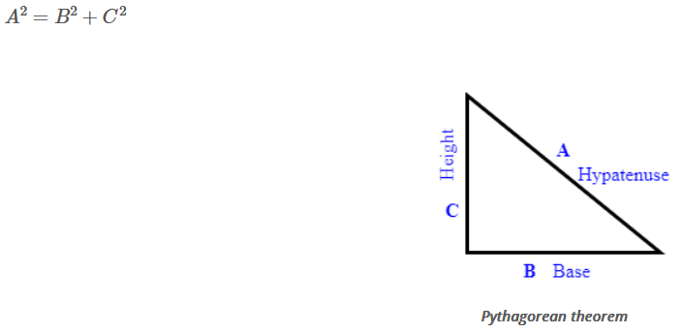
The Pythagorean theorem is applied in various domains of study, like rigid body mechanics, solid mechanics, fluid mechanics, mechanics of materials, and so on.

For example, the Pythagorean theorem is most useful in the determination of forces acting on the structural members of a truss.

Types of Theorem
# Source: Multi sources: Provided by: [Data Path: Persons Table -> ID Column: 1, Name_En Column: Motasem Essam] -> From: [Data Path: Sources Table -> ID Column: 27, Content Title Column: Multi Sources - Theorem - Meaning, Types & Examples] -> at: [Document, page: 2, Types of Theorem, “In mathematics, the following...● Binomial theorem”] on [7/17/2025]
In mathematics, the following few are the important types of theorems widely used in various branches of study:
- Pythagorean theorem
- Sine rule
- Cosine rule
- Mean value theorem
- Mid-point theorem
- Triangle sum theorem
- Isosceles theorem
- Factor theorem
- Binomial theorem

Pythagorean Theorem
# Source: Multi sources: Provided by: [Data Path: Persons Table -> ID Column: 1, Name_En Column: Motasem Essam] -> From: [Data Path: Sources Table -> ID Column: 27, Content Title Column: Multi Sources - Theorem - Meaning, Types & Examples] -> at: [Document, page: 2 TO 3, Pythagorean Theorem, “The Pythagorean theorem the shortest distance.”] on [7/17/2025]
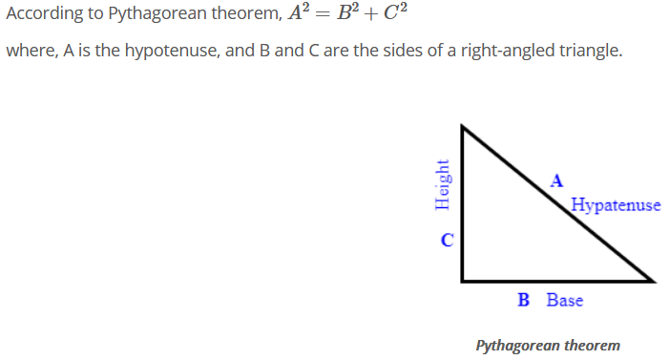
The Pythagorean theorem in mathematics and science can be proved in different ways and is widely used to determine the length of sides, the length of a hypotenuse, the angle made by the hypotenuse with respect to the sides, and trigonometric ratios. A few practical civil engineering applications of the Pythagorean theorem include the surveying of land and forest, building construction, and determination of slope and steepness of mountains and hills. When painting a building, the safe angle of inclination of the ladder with respect to the floor can be determined from the Pythagorean theorem. In the field of photo or video shooting, the setting up of the camera angle can be determined using the Pythagorean theorem. The Pythagorean theorem is used in two-dimensional navigation systems for the determination of the shortest distance.

Sine Rule
# Source: Multi sources: Provided by: [Data Path: Persons Table -> ID Column: 1, Name_En Column: Motasem Essam] -> From: [Data Path: Sources Table -> ID Column: 27, Content Title Column: Multi Sources - Theorem - Meaning, Types & Examples] -> at: [Document, page: 3 to 4, Sine Rule] on [7/17/2025]
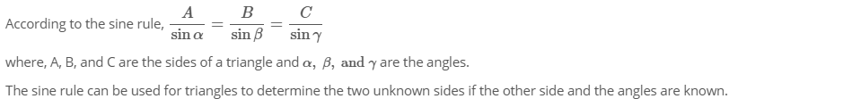


Cosine Rule
# Source: Multi sources: Provided by: [Data Path: Persons Table -> ID Column: 1, Name_En Column: Motasem Essam] -> From: [Data Path: Sources Table -> ID Column: 27, Content Title Column: Multi Sources - Theorem - Meaning, Types & Examples] -> at: [Document, page: 4, Cosine Rule] on [7/17/2025]
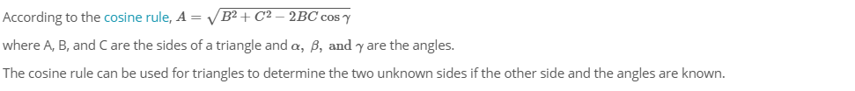


Mean Value Theorem
# Source: Multi sources: Provided by: [Data Path: Persons Table -> ID Column: 1, Name_En Column: Motasem Essam] -> From: [Data Path: Sources Table -> ID Column: 27, Content Title Column: Multi Sources - Theorem - Meaning, Types & Examples] -> at: [Document, page: 4 to 5, Mean Value Theorem] on [7/17/2025]
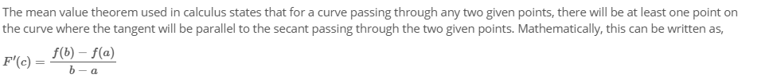
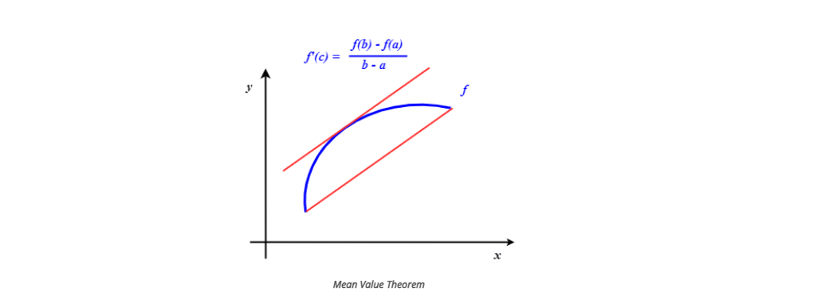

Mid-Point Theorem
# Source: Multi sources: Provided by: [Data Path: Persons Table -> ID Column: 1, Name_En Column: Motasem Essam] -> From: [Data Path: Sources Table -> ID Column: 27, Content Title Column: Multi Sources - Theorem - Meaning, Types & Examples] -> at: [Document, page: 5, Mid-Point Theorem] on [7/17/2025]
The mid-point theorem states that a line joining the mid-points of the two sides of a triangle is parallel to the third side of the triangle and that its length is equal to half of the length of the third side.


Triangle Sum Theorem
# Source: Multi sources: Provided by: [Data Path: Persons Table -> ID Column: 1, Name_En Column: Motasem Essam] -> From: [Data Path: Sources Table -> ID Column: 27, Content Title Column: Multi Sources - Theorem - Meaning, Types & Examples] -> at: [Document, page: 5 to 6, Triangle Sum Theorem] on [7/17/2025]
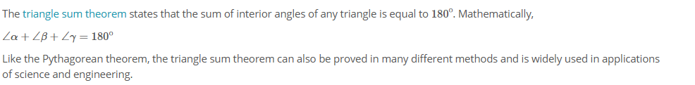


Isosceles Triangle Theorem
# Source: Multi sources: Provided by: [Data Path: Persons Table -> ID Column: 1, Name_En Column: Motasem Essam] -> From: [Data Path: Sources Table -> ID Column: 27, Content Title Column: Multi Sources - Theorem - Meaning, Types & Examples] -> at: [Document, page: 6, Isosceles Triangle Theorem] on [7/17/2025]
The isosceles triangle theorem states that if two sides of a triangle are congruent, then the angles opposite to the sides are congruent. The application of the isosceles triangle theorem can be found on a slice of cake or pizza.


Lami's theorem
# Source: Multi sources: Provided by: [Data Path: Persons Table -> ID Column: 1, Name_En Column: Motasem Essam] -> From: [Data Path: Sources Table -> ID Column: 27, Content Title Column: Multi Sources - Theorem - Meaning, Types & Examples] -> at: [Document, page: 6 to 7, Lami's theorem] on [7/17/2025]
Lami's theorem is similar to the sine law and is used in mechanics to determine the magnitude and direction of the three forces acting at a single point. According to Lami's theorem, if three forces acting at a point are in equilibrium, then each force is directly proportional to the sine angle of the other two forces. This can mathematically be written as,
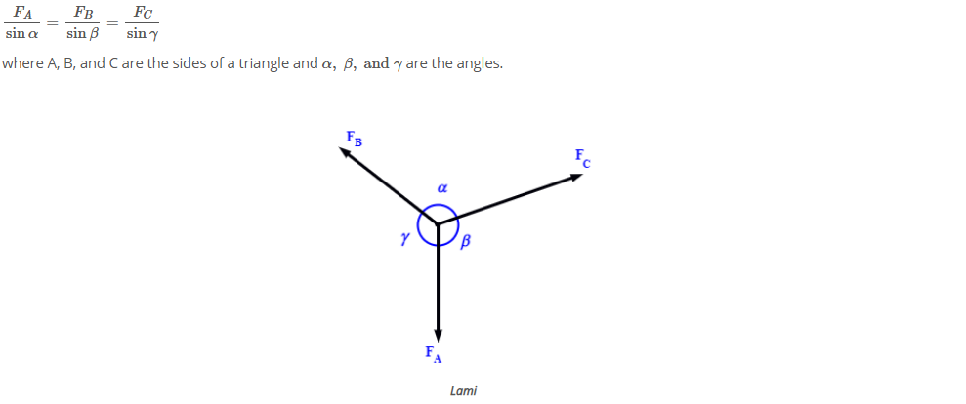

Theorem Examples:
# Source: Multi sources: Provided by: [Data Path: Persons Table -> ID Column: 1, Name_En Column: Motasem Essam] -> From: [Data Path: Sources Table -> ID Column: 27, Content Title Column: Multi Sources - Theorem - Meaning, Types & Examples] -> at: [Document, page: 8, Theorem Examples] on [7/17/2025]
Example 1:
Find the hypotenuse of a right-angled triangle with a of height 3 cm and base 4 cm using the Pythagorean theorem.
Let A be the hypotenuse, B be the base, and C be the height of the triangle.

According to the Pythagorean theorem, the square of the hypotenuse of a right-angled triangle is equal to the sum of the squares of the sides of the triangle. Mathematically,

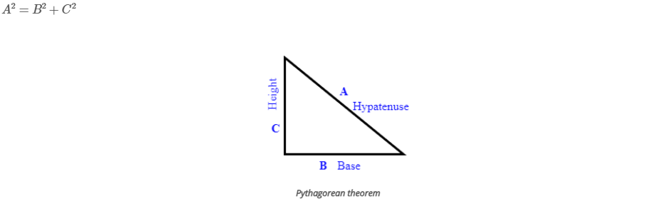

Plug in the given values of the base and the height of the triangle and find the length of the hypotenuse.

Example 2:
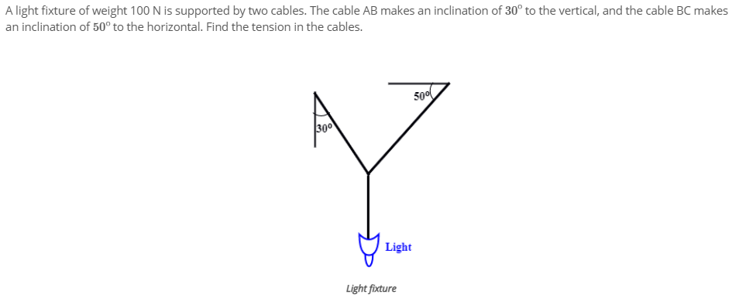
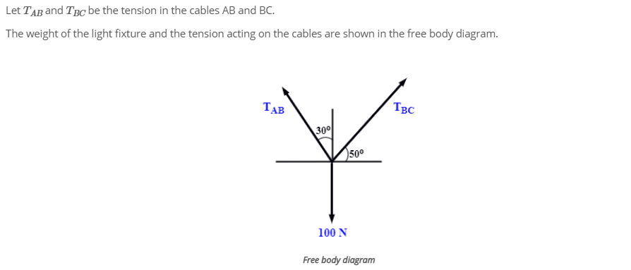
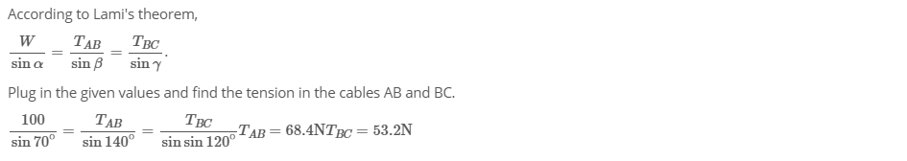

6-Inference rules

Definition
# Source: AI Source: Provided by: [Data Path: Persons Table -> ID Column: 1, Name_En Column: Motasem Essam] -> From: [ChatGPT] on [7/17/2025]
*Inference rules are logical rules that allow us to derive new conclusions from existing statements (or premises). They are fundamental in formal logic, mathematics, computer science (especially in areas like automated reasoning and AI), and philosophy. The idea is that if certain premises are true, we can apply an inference rule to reach a conclusion that must also be true based on those premises.

*Inference rules allow us to move from one or more statements (premises) to a new statement (conclusion) based on logic. They form the foundation of deductive reasoning and are used in many areas of mathematics, computer science, and philosophy to prove the validity of arguments and solve problems.

Examples
# Source: AI Source: Provided by: [Data Path: Persons Table -> ID Column: 1, Name_En Column: Motasem Essam] -> From: [ChatGPT] on [7/17/2025]
1- Modus Ponens (Direct Inference)
- Rule: If "P → Q" (If P, then Q) is true, and P is true, then Q must also be true.
- Example:
  - Premise 1: If it rains, the ground will be wet. (P → Q)
  - Premise 2: It is raining. (P)
  - Conclusion: The ground is wet. (Q)

2- Modus Tollens (Denying the Consequent)
- Rule: If "P → Q" (If P, then Q) is true, and Q is false, then P must also be false.
- Example:
  - Premise 1: If the light is on, the room is bright. (P → Q)
  - Premise 2: The room is not bright. (¬Q)
  - Conclusion: The light is not on. (¬P)
3- Hypothetical Syllogism
- Rule: If "P → Q" (If P, then Q) and "Q → R" (If Q, then R) are true, then "P → R" (If P, then R) must also be true.
- Example:
  - Premise 1: If I study, I will pass the exam. (P → Q)
  - Premise 2: If I pass the exam, I will get a degree. (Q → R)
  - Conclusion: If I study, I will get a degree. (P → R)
4- Disjunctive Syllogism
- Rule: If "P ∨ Q" (P or Q) is true, and P is false, then Q must be true.
- Example:
  - Premise 1: Either it is raining or it is snowing. (P ∨ Q)
  - Premise 2: It is not raining. (¬P)
  - Conclusion: It is snowing. (Q)

5- Affirming the Consequent (Fallacy)
- Rule: This is an invalid inference rule where one incorrectly assumes that if "P → Q" (If P, then Q) is true, and Q is true, then P must also be true.
- Example (Invalid):
  - Premise 1: If it rains, the ground will be wet. (P → Q)
  - Premise 2: The ground is wet. (Q)
  - Conclusion: It must have rained. (P) — This is a fallacy because the wet ground could be due to other reasons like someone watering the plants.
6- Constructive Dilemma
- Rule: If "(P → Q)" and "(R → S)" are true, and "P ∨ R" is true, then "Q ∨ S" must also be true.
- Example:
  - Premise 1: If I study, I will pass the exam. (P → Q)
  - Premise 2: If I work, I will earn money. (R → S)
  - Premise 3: Either I will study or I will work. (P ∨ R)
  - Conclusion: Either I will pass the exam or I will earn money. (Q ∨ S)
7- Conjunction
- Rule: If P is true and Q is true, then "P ∧ Q" (P and Q) is true.
- Example:
  - Premise 1: It is raining. (P)
  - Premise 2: It is cold. (Q)
  - Conclusion: It is raining and it is cold. (P ∧ Q)
8- Simplification
- Rule: If "P ∧ Q" (P and Q) is true, then P is true, and Q is also true.
- Example:
  - Premise: It is raining and it is cold. (P ∧ Q)
  - Conclusion: It is raining. (P)

